ECS NOTES:

# Build Stage
FROM node:24-slim AS builder
WORKDIR /app
COPY app .
RUN yarn install && yarn build

# Runtime Stage
FROM nginx:1.30.3-alpine
COPY --from=builder /app/build/ /usr/share/nginx/html/
EXPOSE 80
RUN chown -R nginx:nginx /var/cache/nginx
USER nginx

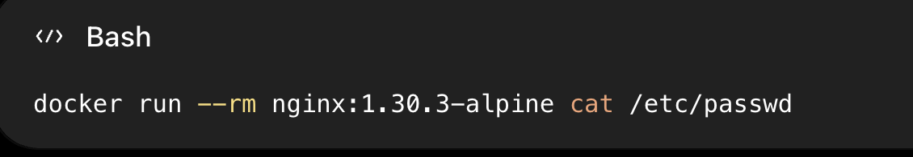
tells us:
"What user accounts exist inside the nginx:1.30.3-alpine image?"

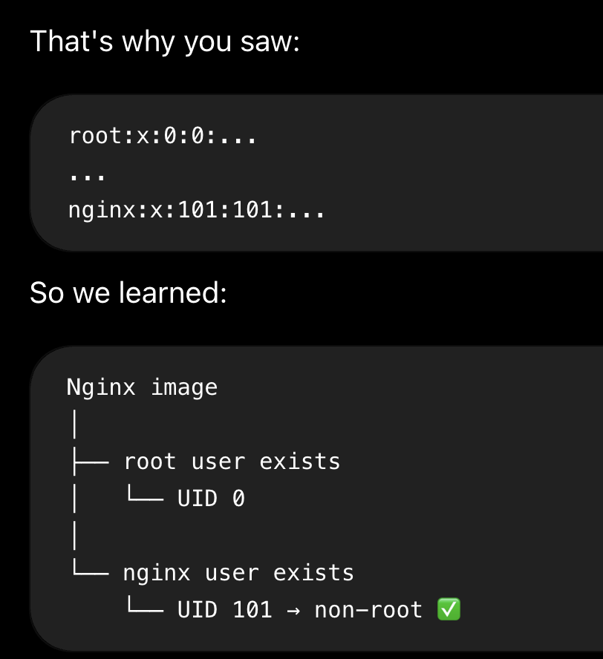
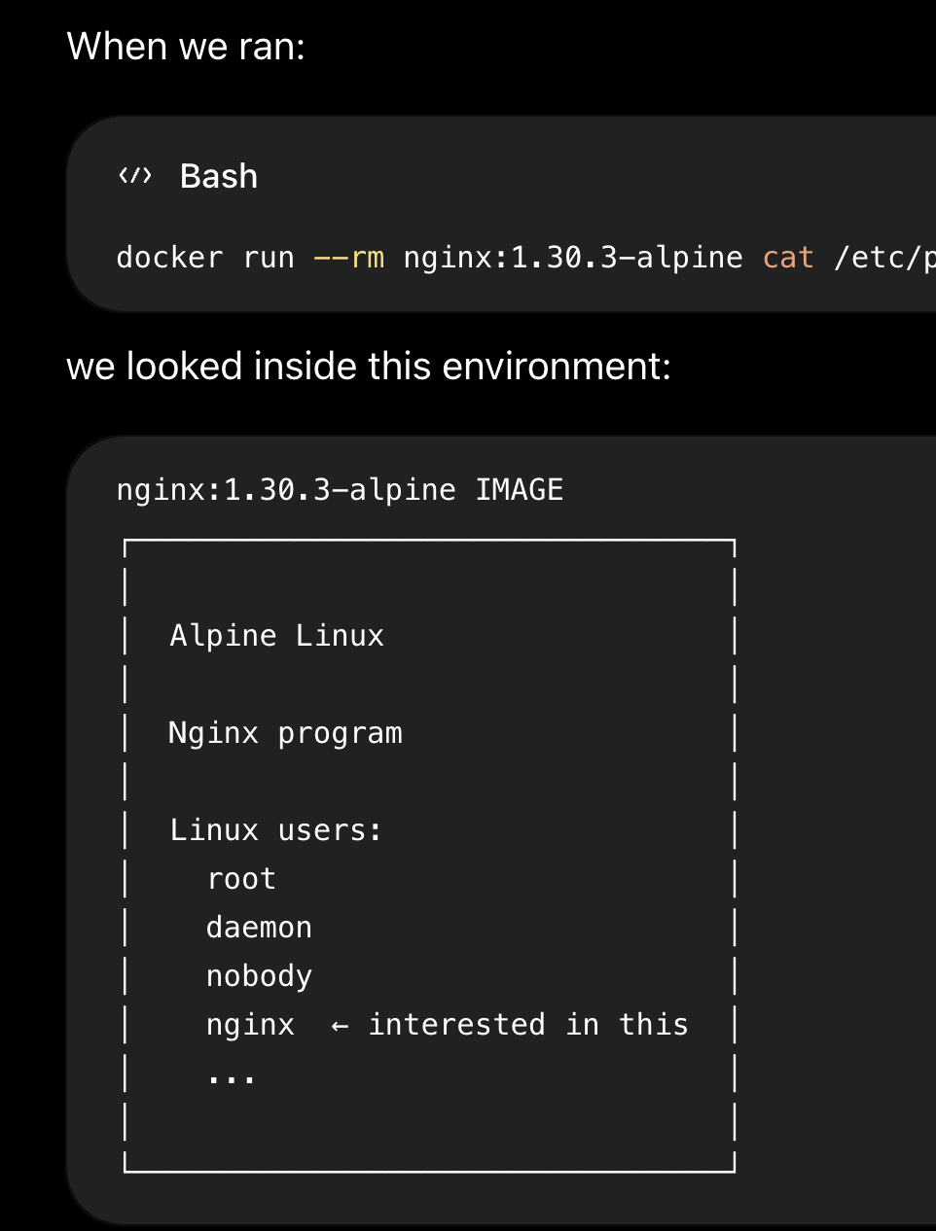

So we were just checking the users of that image. "What Linux users exist inside this Nginx image?"

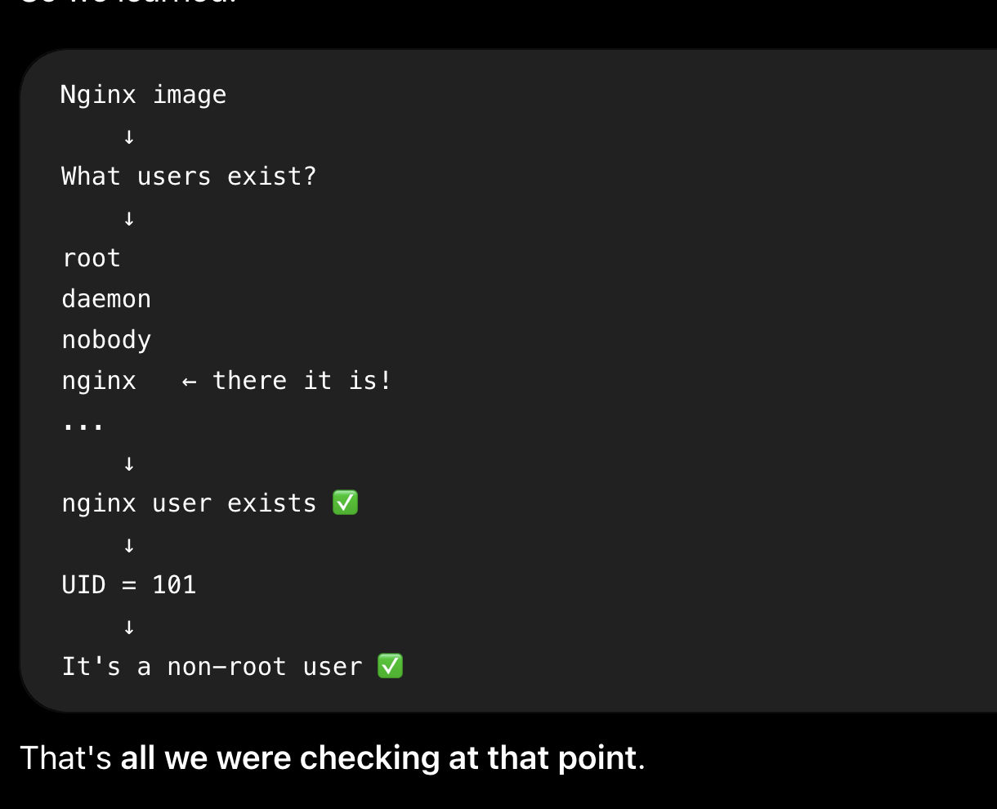
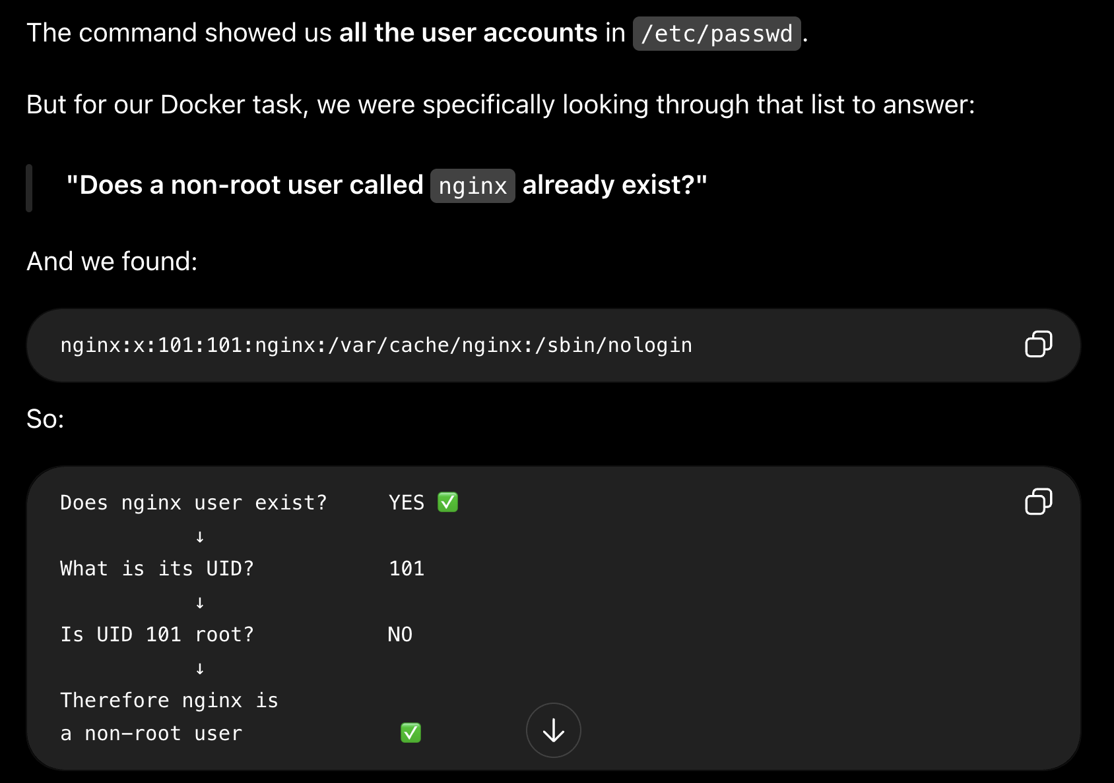
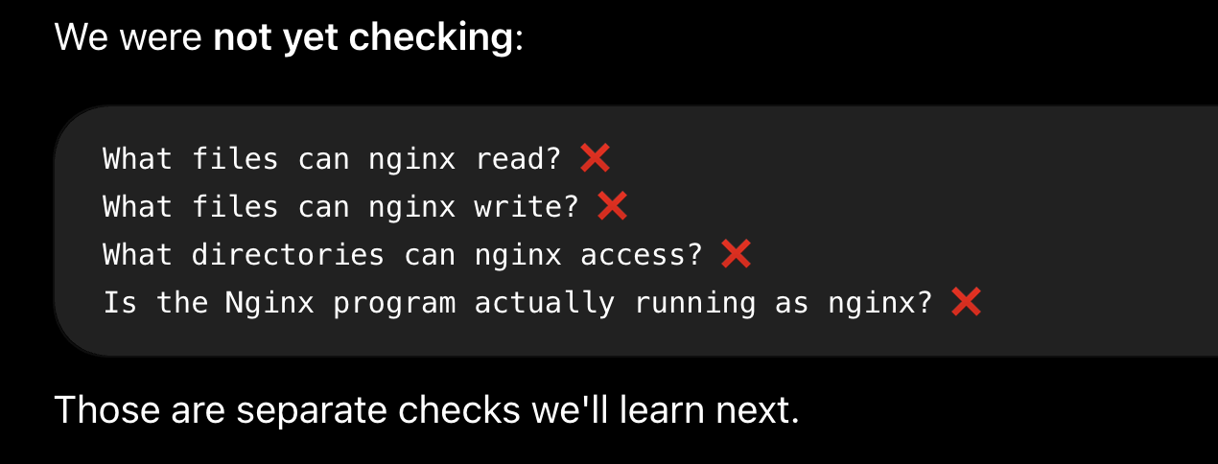

Why did we run cat /etc/passwd inside the Nginx image?
A perfect answer would be:
"To see what Linux users exist in the Nginx image and check whether it already has a non-root nginx user."

Next, we want to answer:
Does the nginx user have the access it needs to our website directory?

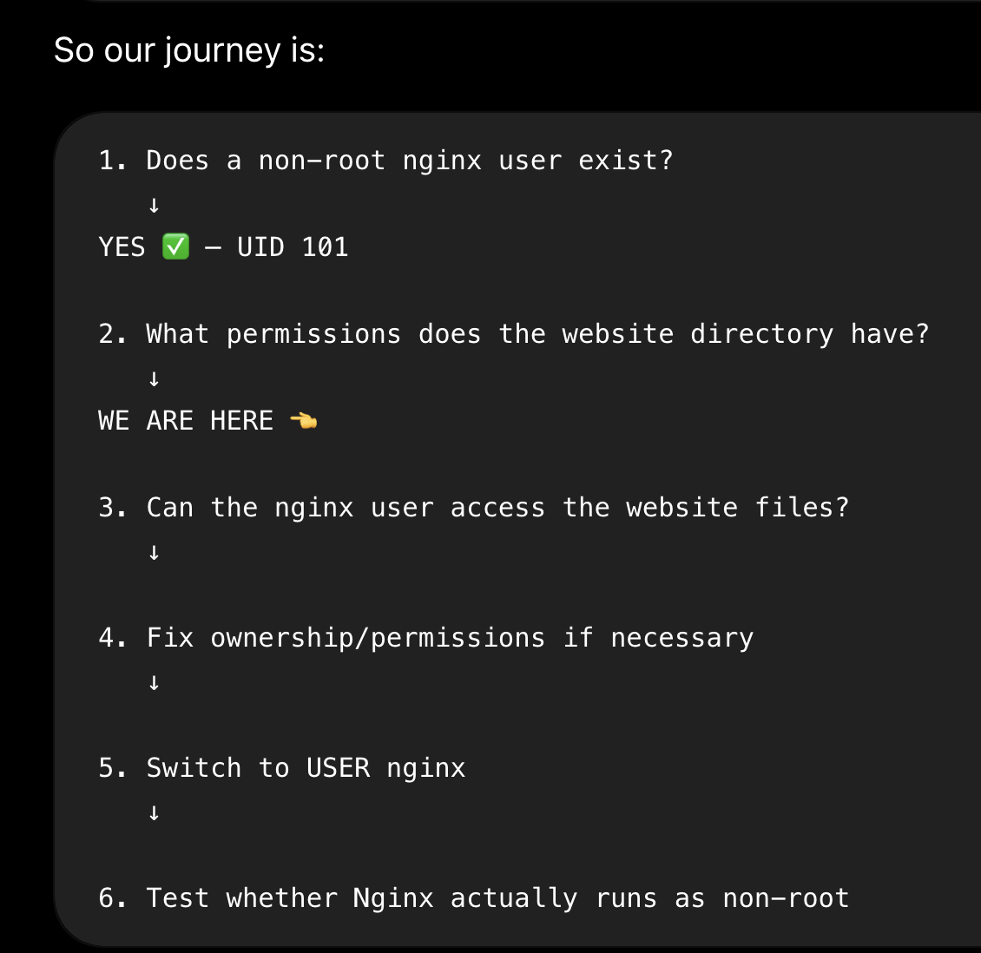

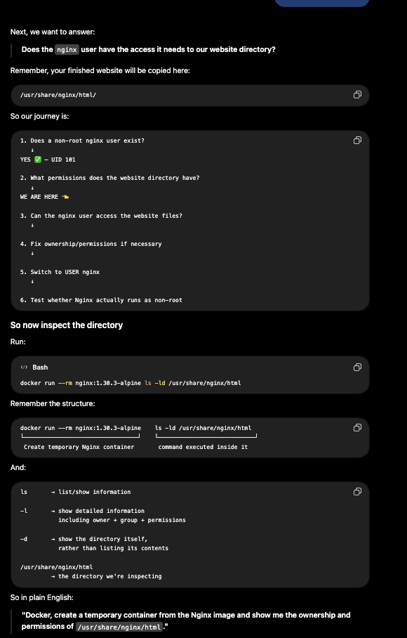

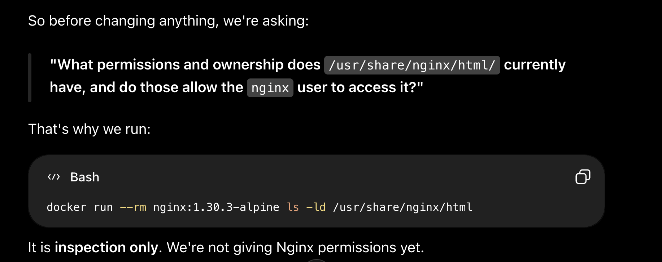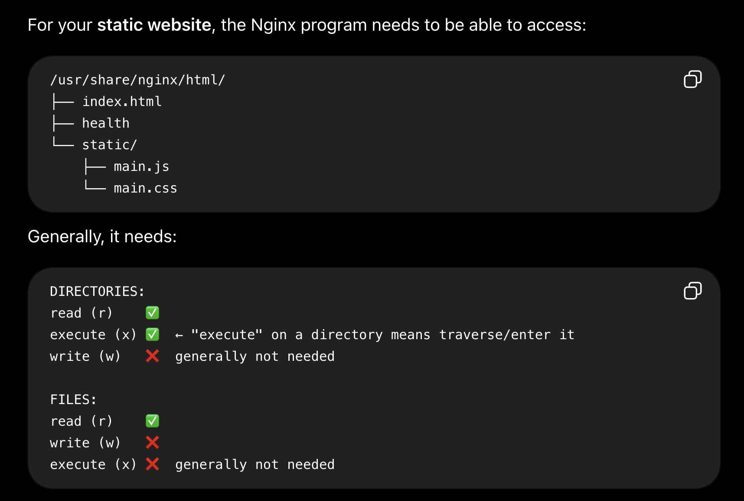

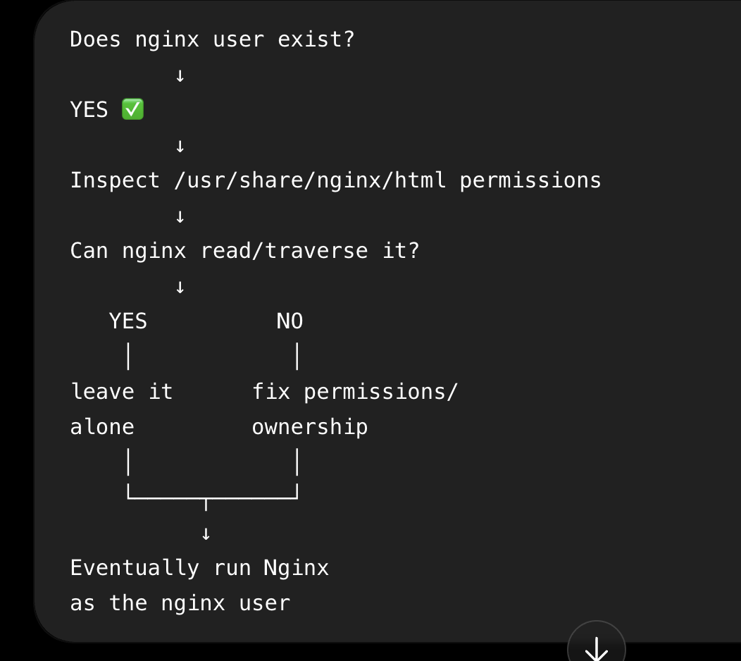

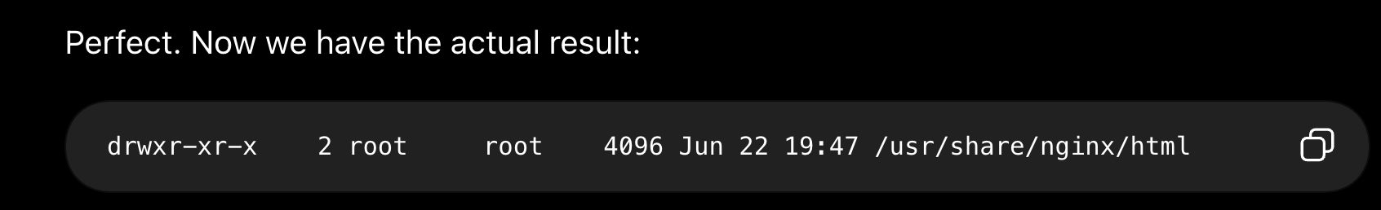

We want to run Nginx as a non-root user because of the principle of least privilege: Nginx only needs enough permission to serve our static website, so there is no reason to give the Nginx process the powerful root account if we can avoid it. First, we needed to find out whether the nginx:1.30.3-alpine image already contained a suitable non-root user, rather than unnecessarily creating our own. We ran docker run --rm nginx:1.30.3-alpine cat /etc/passwd, which creates a temporary container from the Nginx image, prints /etc/passwd (the file containing the Linux user accounts), and removes the temporary container when it finishes. In the output we found nginx:x:101:101:..., which showed that a user named nginx already exists and has UID 101; because root has UID 0, nginx is a non-root user. Next, because our production website is copied into /usr/share/nginx/html/, we needed to determine whether this nginx user has enough permission to access that directory. We ran docker run --rm nginx:1.30.3-alpine ls -ld /usr/share/nginx/html, which returned drwxr-xr-x ... root root .... The two root values tell us that the directory's owner user is root and its owning group is the group named root. The permission string divides into three categories: rwx | r-x | r-x, where the first category is OWNER, the second is GROUP, and the third is OTHERS. Therefore, the owner (root user) gets rwx — read, write and traverse — while members using the owning root group's permissions get r-x — read and traverse — and others also get r-x. We already know the nginx user isn't the owner because the owner is root, but before saying nginx definitely falls under OTHERS, we need to check whether nginx belongs to the directory's owning root group. That's why our next command is docker run --rm nginx:1.30.3-alpine id nginx: it shows the nginx user's UID and group memberships. If it confirms that nginx is not a member of the root group, then for this directory nginx uses the OTHERS (r-x) permissions, meaning it can read and traverse /usr/share/nginx/html/, but cannot write to it.
There can be many Linux users, and "others" isn't a specific group called others. It's a permission category meaning users who are neither the file/directory's owner nor using its owning group's permissions.

We then ran docker run --rm nginx:1.30.3-alpine id nginx to check the identity and group membership of the nginx user. The output showed uid=101(nginx) gid=101(nginx) groups=101(nginx),101(nginx), confirming that nginx is a non-root user with UID 101 and belongs to the nginx group, not the root group. We compared this with the ownership and permissions of /usr/share/nginx/html, which were drwxr-xr-x root root. This directory is owned by the root user and associated with the root group, so because nginx is neither the owner nor a member of that owning group, Linux applies the OTHERS permissions to it. The OTHERS permissions are r-x, meaning the nginx user can read (r) and traverse (x) the /usr/share/nginx/html directory, but cannot write (-) to it. This is suitable for our static website directory because Nginx needs to access and serve the website files, but it generally does not need to modify them.
So the next step is to check if the container already starts as a non-root user, if it doesn’t, then we switch to a non-root user.
A non-root user existing in the image does not mean the container is using that user.
So yes, we check what user the container starts as. If it's root, then we work on switching it to a suitable non-root user such as nginx.

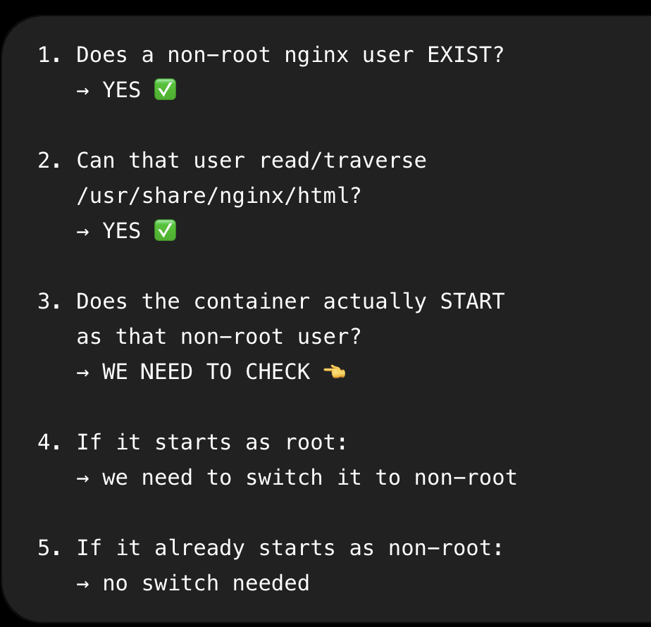
We then needed to check whether the Nginx image is actually configured to start containers as the non-root nginx user. We ran docker inspect 0d3b80406a13 --format '{{.Config.User}}', where docker inspect examines the image's Docker configuration, 0d3b80406a13 is the ID of our nginx:1.30.3-alpine image, and {{.Config.User}} asks specifically for the user configured to run the container. The command returned a blank value, meaning the image does not explicitly configure a user with Docker's USER setting, so Docker defaults to running the container as root. Therefore, although we previously confirmed that the image already contains a non-root user called nginx (UID 101), the container does not automatically start as that user. This means that to meet our requirement of running Nginx as non-root, we will need to explicitly switch to an appropriate non-root user, such as with USER nginx, after making sure Nginx can still access everything it needs to start and run correctly.
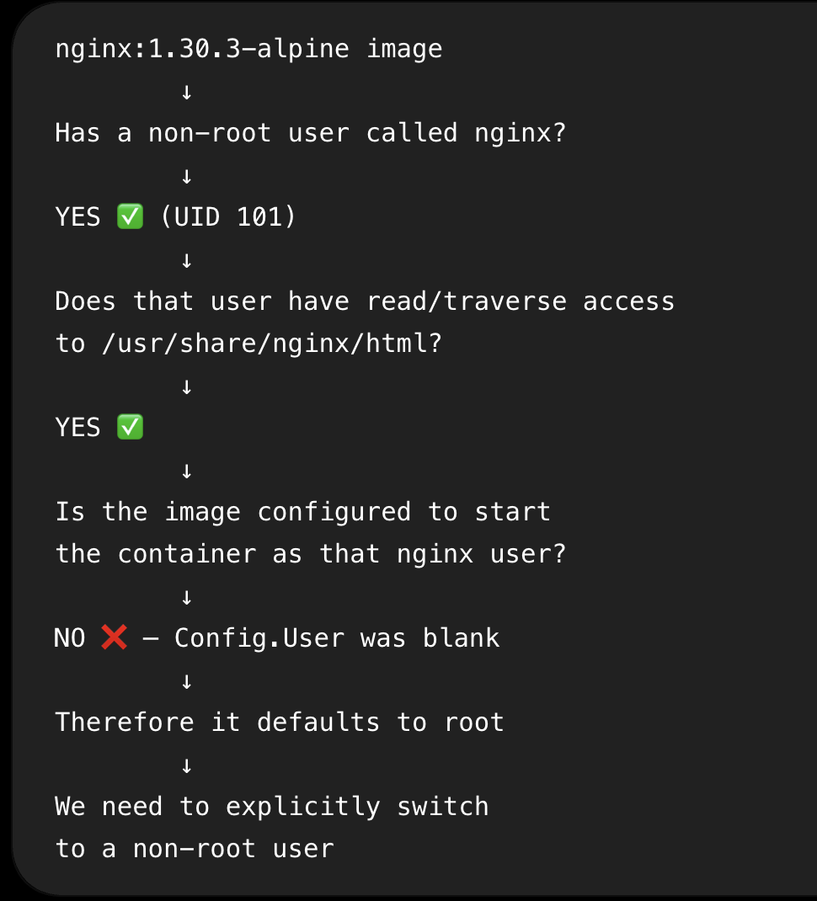

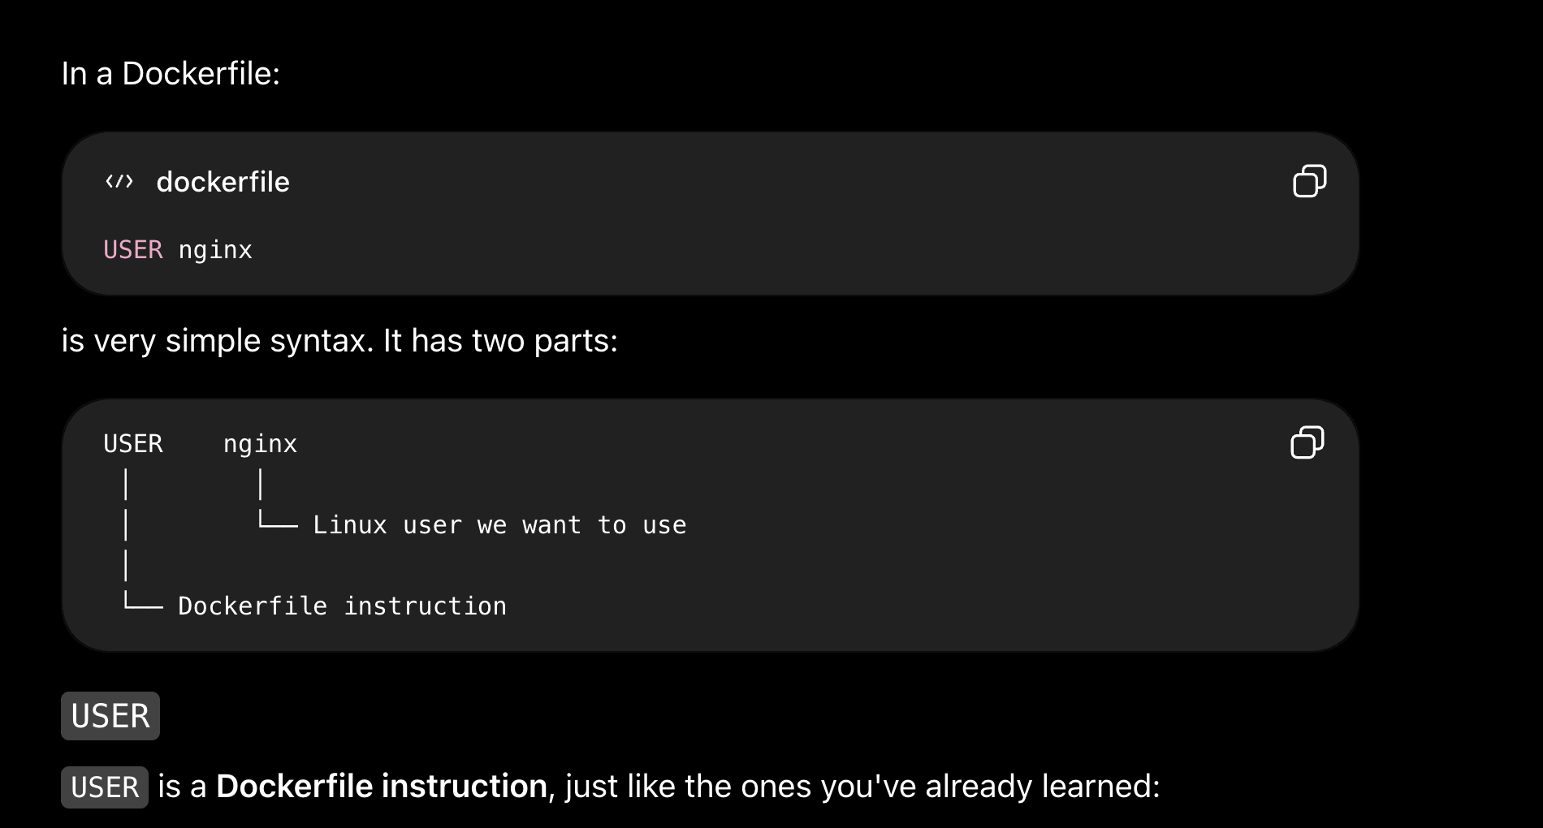

USER tells Docker:
"From this point onward, use this user for subsequent applicable instructions and for the container's process when it starts."

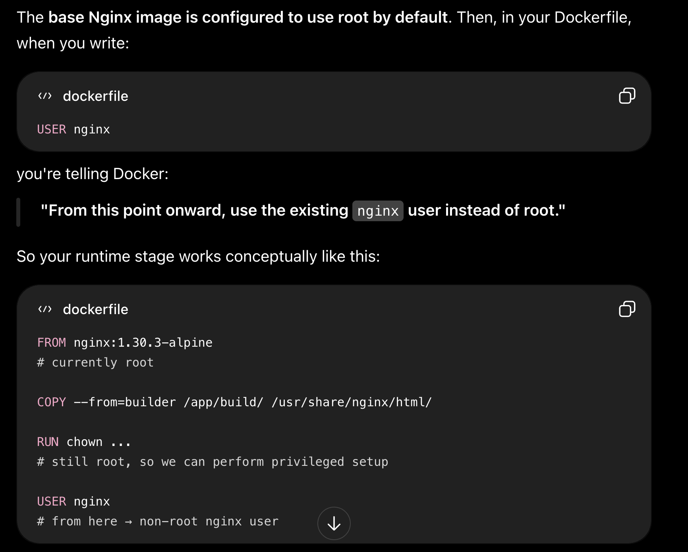

RUN chown -R nginx:nginx /var/cache/nginx
means:
During the image build, change the ownership of /var/cache/nginx and everything inside it so the owner is the nginx user and the owning group is the nginx group. "Make the nginx user and nginx group own /var/cache/nginx and its contents, because the Nginx process running as nginx needs to write there." “Make the Linux user named nginx the owner of /var/cache/nginx.”

We made the Linux user nginx the owner of /var/cache/nginx because the Nginx web-server program, which we want to run as that user, needs to write temporary/runtime files there.

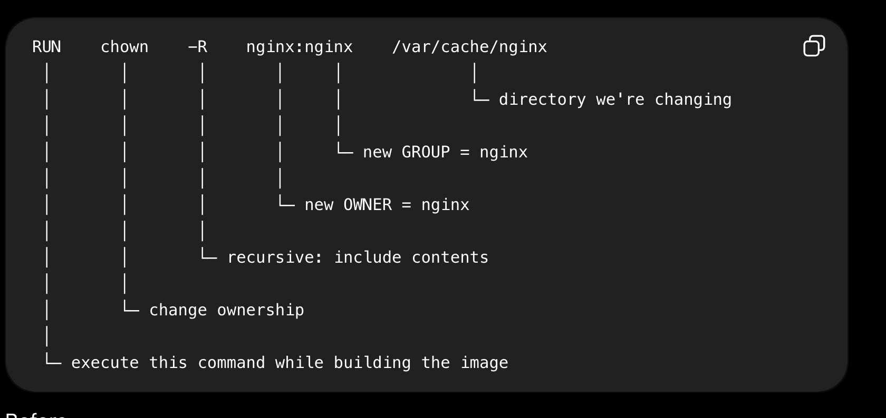

USER nginx
does not remove that write permission.
Instead, USER nginx says:
"Now that root has finished preparing everything, stop using root and run subsequent commands/the final container process as the restricted nginx user."

For the non-root user part of the task, our goal was to make sure the final Nginx container does not run its web-server process as the powerful root user, following the principle of least privilege. We first pulled the runtime image with docker pull nginx:1.30.3-alpine. Because an image may already contain a suitable non-root Linux user, we checked the users inside the Nginx image by running docker run --rm nginx:1.30.3-alpine cat /etc/passwd. This showed several Linux/system users, including nginx:x:101:101:..., which told us that a Linux user called nginx already exists and has UID 101; since the root user has UID 0, we established that nginx is a non-root user, meaning we did not need to create a new user ourselves. We then needed to make sure this user could access the static website that we copy into /usr/share/nginx/html/, so we ran docker run --rm nginx:1.30.3-alpine ls -ld /usr/share/nginx/html. The result was drwxr-xr-x ... root root ..., telling us that the directory is owned by the root user, associated with the root group, and has permissions rwx | r-x | r-x for OWNER | GROUP | OTHERS respectively. We then ran docker run --rm nginx:1.30.3-alpine id nginx and got uid=101(nginx) gid=101(nginx) groups=101(nginx),101(nginx). This confirmed that nginx is not the directory's owner (root) and is not using the owning root group's permissions, so for /usr/share/nginx/html it falls under OTHERS and receives r-x: it can read and traverse the website directory but cannot write to it, which is appropriate because Nginx needs to serve the static files rather than modify them. Next, we checked whether the base image was actually configured to start containers as this non-root user. We ran docker inspect 0d3b80406a13 --format '{{.Config.User}}', using the image ID after verifying it with docker images. The result was blank, meaning the image does not explicitly configure a Docker USER, so it effectively defaults to root. Therefore, although the non-root nginx user exists, the final container would not automatically run as that user, meaning we need USER nginx in our Dockerfile. Before blindly adding it, however, we tested whether Nginx could actually operate as that user with docker run --rm --user nginx nginx:1.30.3-alpine. Nginx attempted to start but failed with mkdir() "/var/cache/nginx/client_temp" failed (13: Permission denied). This taught us that Nginx doesn't only need to read our website files; while running, it also needs to write temporary/runtime data under /var/cache/nginx. We inspected that directory with docker run --rm nginx:1.30.3-alpine ls -ld /var/cache/nginx and again found drwxr-xr-x ... root root .... Because nginx is neither the root owner nor using the root group's permissions, it gets the OTHERS permissions r-x, meaning it cannot write there, which explained the error. Therefore, in the Nginx runtime stage of our Dockerfile, while we are still operating as root, we use RUN chown -R nginx:nginx /var/cache/nginx. The chown command changes ownership, -R applies the change recursively, nginx:nginx means the new owner is the nginx user and the new owning group is the nginx group, and /var/cache/nginx is the directory being changed. This makes nginx the owner of that runtime directory, so the owner permissions rwx apply to it and it can create the temporary files Nginx needs. Only after root has completed this privileged setup do we use USER nginx, which switches subsequent applicable operations and the final container process from root to the restricted non-root nginx user. As a result, the Nginx program will run as a non-root user, that user has only r-x access to /usr/share/nginx/html where it only needs to serve the website, while it has the necessary write access to /var/cache/nginx where Nginx needs to create runtime files. This is the principle of least privilege: use root temporarily during the image build to perform administrative setup, then run the actual application as a restricted non-root user with only the permissions it needs.

